

Coding Conventions

C#, Onix Work

Coding Conventions SQL Server

# Revision History

|  |  |  |  |
| --- | --- | --- | --- |
| No | Date | Content | Author |
| 1 | 30.10.2018 | Create first version | nt |
|  |  |  |  |

# Approvals

|  |  |  |  |
| --- | --- | --- | --- |
| No | Date | Role | Approved By |
|  |  |  |  |

# **Table of Contents**

C#, Onix Work

Revision History 1

Approvals 1

**Table of Contents** 2

**Table of Figures** 2

Introduction 3

Purpose 3

Related Documents 3

SQL Server 4

**Naming Conventions** 4

**Indentation** 6

**Layout** 6

**Exception Handling** 7

# **Table of Figures**

No table of figures entries found.

# Introduction

## Purpose

The purpose of this document is describing about our code conventions

## Related Documents

-

# **C#, Onix Work**

### Naming Conventions

All databases objects (except keys, indexes) should be named by following rule:

* Pascal Case.
* Avoid blank space, special characters in name.
* Avoid using underscore between words.
* Avoid using any prefix, for example v for view, sp for stored procedure, f for function, etc.

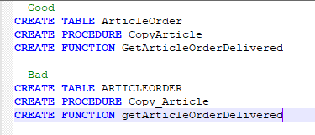

1. Table, View, Columns

* Column which is Primary Key, auto-increamenting, identity integer value is named as <TableName>Id.
* Columns which are Foreign Key are named as <RefTableName>Id.
* Use singular noun for table name.

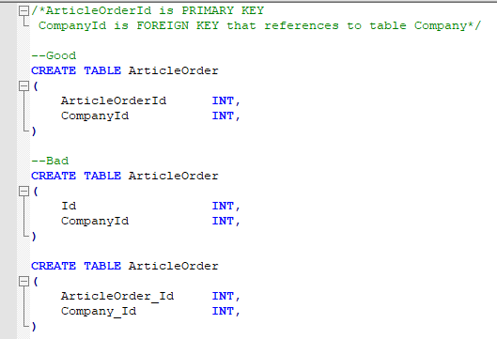

1. Key and Index

* Keys should be created manually to avoid random name by system.
* Have underscore between key type and table name.
* Have prefix PK_ if it is primary key, FK_ if it is foreign key, IDX_ if it is an index.
* Key and Index should be named as <Type of Key>_<TableName>_<ColumnName>

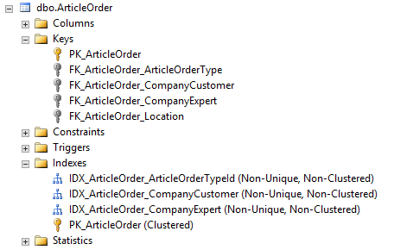

1. Stored Procedure and Function

* Should be named as <Action><Object>

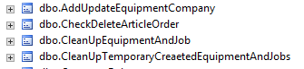

* Parameters should be named follow common rule.

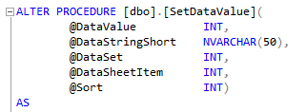

### Indentation

Use four (4) space indents for blocks.

Use four (4) for tabs.

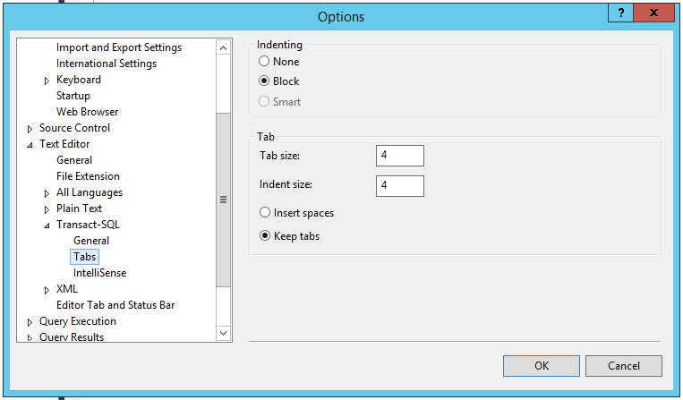

### Layout

* All SQL keywords are capitalized:

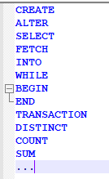

* Code block between BEGIN and END should have one (1) tab compared with BEGIN/END

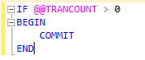

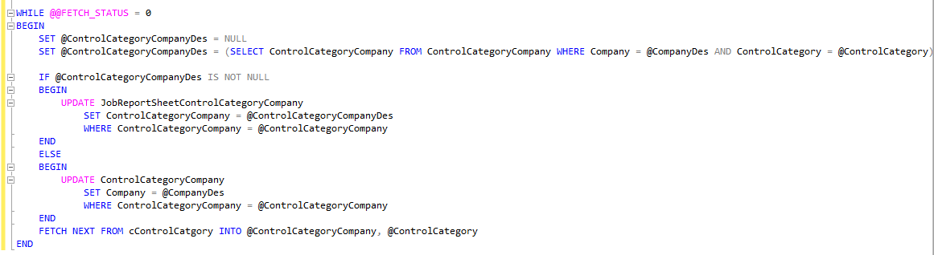

* Use as much as alias in Select statement.

### Exception Handling

Try to wrap all UPDATE/INSERT/DELETE statement in a TRY … CATCH block with transaction.

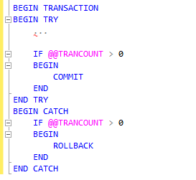

### Comment

Standard comment MUST be added at the first-time stored procedure or function created. Comment should be place on the top of the stored procedure/function to explain its purpose and meaning/usage of parameters if there is any.

-- =============================================

-- Name: <Name of SP or Function>

-- Description: <Description>

-- Parameters:

-- @Param1: <Meaning/Usage>

-- @Param2: <Meaning/Usage>

-- =============================================

Whenever the code needs to be updated or added more, a comment should be added to describe the change. Moreover, bugs/feature Id should be included in comment.

-- =============================================

-- Name: <Name of SP or Function>

-- Description: <Description>

-- Parameters:

-- @Param1: <Meaning/Usage>

-- @Param2: <Meaning/Usage>

-- =============================================

-- =============================================

-- Fix bug 01

-- Description <Description>

--

-- Fix bug 02

-- Description <Description>

-- =============================================